AI-BASED RETINAL DISEASE DETECTION AND AUTOMATED DIABETIC RETINOPATHY GRADING USING DEEP LEARNING
Angel Sweety P
Department of Computer Science and Engineering (Artificial Intelligence)
Karunya Institute of Technology and Science
Coimbatore, India
angelsweety@karunya.edu.in

Abstract—This study evaluates EfficientNetB3 for assigning retinal fundus images to five diabetic retinopathy (DR) grades and integrates the classifier into a web application. The image collection contains 107,859 samples, with 79,431 allocated to training, 14,227 to validation, and 14,201 to testing. Following preprocessing, the network returns a grade and its associated probability. A Grad-CAM overlay accompanies the prediction to help users examine the image regions associated with the model response. On the test set, 8,488 images were classified correctly, giving an accuracy of 59.77% and a micro-average ROC-AUC of 0.8350. Performance differed substantially by grade: recall reached 79.08% for No DR and 73.60% for Proliferative DR, but only 21.14% for Moderate DR. These findings identify intermediate-grade discrimination as a major limitation of the present model. The Flask application brings image upload, grading, confidence display, and visual explanation into one interface. It remains a research prototype rather than a clinically validated diagnostic system.
Index Terms—Diabetic retinopathy, EfficientNetB3, retinal fundus images, deep learning, Grad-CAM, image classification.

I. INTRODUCTION
Diabetic retinopathy (DR) affects the retinal blood vessels and can threaten vision as the disease advances. Fundus photographs provide a record of retinal appearance that can be examined for disease-related changes. Automated analysis of these photographs has therefore attracted attention as a means of supporting DR assessment [1], [3].
Interpreting a fundus image requires attention to both the visible abnormalities and the quality of the photograph. Reviewing large image collections places demands on specialist time, while subtle findings can make severity grading difficult. These practical constraints motivate the development of computational tools that assist image review [3], [6].
Convolutional networks learn image representations from labelled examples. Their use in DR research extends from locating retinal lesions to assigning an image-level disease grade [1], [5]. For a grading system, the central question is whether those representations distinguish neighbouring severity categories reliably.
We investigate this question using EfficientNetB3 with five output labels: No DR, Mild DR, Moderate DR, Severe DR, and Proliferative DR, corresponding to Grades 0–4. The network assigns one label to each preprocessed fundus image.
The experiment uses separate training, validation, and test subsets from a collection of 107,859 images. Because the grade frequencies are unequal, the evaluation includes per-class measures as well as overall accuracy. This makes weaknesses in less successfully recognised grades visible.
A Grad-CAM overlay adds spatial context to the predicted label by highlighting regions associated with the network response. The overlay supports inspection of the prediction; it does not establish that the highlighted areas are clinically verified lesions.
The trained classifier is accessed through a web interface. Users upload a fundus photograph and receive the predicted grade, class probability, heatmap, and a grade-dependent recommendation. Predictions at higher grades prompt specialist consultation. The application is intended for research use and cannot substitute for professional assessment.
The study examines the complete path from image input to result presentation, with particular attention to errors between disease grades. Accuracy, precision, recall, F1-score, the confusion matrix, and ROC-AUC describe complementary aspects of performance.

II. RELATED WORK
Research on automated DR assessment covers several related problems, including image-level classification, progression prediction, lesion detection, and segmentation. The reviews cited below provide context for the present grading experiment.
Sebastian et al. [1] surveyed deep learning approaches to DR classification, considering the datasets and methods used to detect and grade disease. Their discussion places classification performance alongside the difficulties encountered in automated retinal analysis.
Usman et al. [2] focused on machine learning models for predicting DR progression. Their review of studies from 2017–2023 examined limitations in risk prediction and areas requiring further investigation. Progression prediction differs from the image-level severity assignment examined here.
Sarki et al. [3] examined deep learning techniques for DR detection from fundus photographs. They discussed convolutional approaches, retinal datasets, and the challenges involved in applying these methods to medical images.
The review attributed to Tymchenko et al. [4] addresses preparation of retinal data, preprocessing, grading, and lesion localisation, together with questions surrounding clinical application.
Alyoubi et al. [5] considered computer-aided DR assessment across detection, segmentation, and classification tasks. This wider scope helps distinguish a severity classifier from systems designed to identify individual retinal abnormalities.
Shekar et al. [6] discussed machine learning and deep learning methods alongside retinal datasets and evaluation measures. Their review also considered technical and clinical obstacles to automated analysis.
Naz et al. [7] reviewed supervised and unsupervised approaches, covering more than one hundred articles on datasets, preprocessing, segmentation, and deep learning. Their work situates DR detection within a range of learning strategies.
The review listed in [8] brings together segmentation, prediction, identification, and classification studies. It discusses reported performance across network architectures and outlines unresolved research challenges.
Across this literature, reported outcomes depend on the data, image preparation, model, and assessment task. These differences limit direct comparisons between studies. Reliable separation of severity grades remains the specific concern of the present experiment.
Our implementation combines five-class EfficientNetB3 inference with Grad-CAM and a browser-based result page. Its evaluation emphasises the distribution of errors across grades, rather than treating a single aggregate score as sufficient evidence of performance.

III. PROPOSED METHODOLOGY
Figure 1 outlines the processing sequence. Retinal images are prepared for EfficientNetB3, the network estimates five class probabilities, and the most probable class becomes the predicted grade. Grad-CAM then supplies an overlay for the selected output. A Flask application coordinates these steps and presents the result.

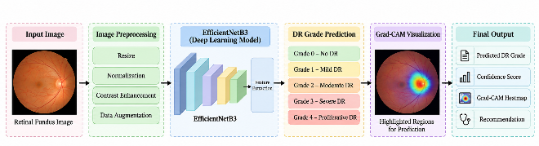

Fig. 1. Overall Architecture of the Proposed DR Grading System
A. Dataset Preparation
Each image is associated with one of the five DR labels, from Grade 0 (No DR) to Grade 4 (Proliferative DR). The complete collection contains 107,859 fundus images; Table I gives the count for each grade and data subset.
The training subset contains 79,431 images. Validation uses 14,227 images, while the remaining 14,201 form the held-out test subset. Evaluation retains the individual grade labels so that class imbalance does not obscure differences in recognition performance.
B. Image Preprocessing
Preprocessing brings the fundus photographs into a common input representation. Images are resized for the network, and pixel values are normalised before inference or training. These operations address differences in input dimensions and numerical scale.
The preparation workflow also includes contrast enhancement and consideration of training-time augmentation. Candidate transformations include rotation, reflection, zoom, and brightness adjustment. Their role is to expose the network to variation in the training images.
C. EfficientNetB3 Model
EfficientNetB3 extracts a learned representation from each prepared image. Its convolutional features feed a classification layer that produces an output for each of the five severity categories.
Inference selects the category with the largest predicted probability. The interface displays that value as a confidence score. This score describes the network output; no probability-calibration assessment is reported in this experiment.
D. Diabetic Retinopathy Grading
The five output categories follow increasing disease severity: No DR, Mild, Moderate, Severe, and Proliferative DR. A Grade 0 prediction indicates the model selected the No DR category; Grade 4 denotes its Proliferative DR category.
For evaluation, each predicted category is matched against the corresponding test label. Counting matches and errors separately by grade provides a more informative assessment than pooling all predictions alone.
E. Grad-CAM Visualization
For the predicted class, Grad-CAM derives a spatial heatmap from the network’s convolutional representations. The map provides an indication of the regions associated with that class response.
The application superimposes the map on the input photograph. This allows the user to inspect the spatial pattern alongside the classification, without treating the overlay as an independent diagnostic finding.
F. Result Generation
The result page brings together the uploaded photograph, predicted severity, confidence value, and heatmap. A recommendation linked to the predicted grade appears with these outputs.
HTML, CSS, Bootstrap, and JavaScript provide the interface, while a Python Flask backend manages image preparation and model execution. The same backend generates the Grad-CAM output and returns the information needed by the result page.
G. Model Evaluation
The held-out test set is assessed using accuracy, precision, recall, F1-score, and ROC-AUC. The confusion matrix records which labels are selected for each true grade, exposing errors that an aggregate accuracy value cannot describe.
Per-class findings are interpreted together with the overall measures. This is necessary because the model’s ability to recognise one grade does not imply comparable performance on the remaining grades.

IV. DATASET AND EXPERIMENTAL SETUP
A. Dataset Description
Table I summarises the 107,859-image collection. The split assigns 79,431 images to parameter learning, 14,227 to validation, and 14,201 to final testing. Test images are excluded from parameter learning. All three subsets contain examples of the five severity categories.

TABLE I
DISTRIBUTION OF RETINAL FUNDUS IMAGE DATASET

Class | DR Grade | Training | Validation | Testing | Total
No DR | Grade 0 | 21,844 | 6,895 | 6,896 | 35,635
Mild DR | Grade 1 | 18,470 | 1,840 | 1,862 | 22,172
Moderate DR | Grade 2 | 21,706 | 3,024 | 2,999 | 27,729
Severe DR | Grade 3 | 7,936 | 1,000 | 978 | 9,914
Proliferative DR | Grade 4 | 9,475 | 1,468 | 1,466 | 12,409
Total | — | 79,431 | 14,227 | 14,201 | 107,859

No DR is the largest category in the collection, with 35,635 images; Severe DR is the smallest, with 9,914. This uneven distribution is one reason to inspect recall and F1-score for every grade.

B. Experimental Setup
The experiment uses EfficientNetB3 as the image classifier. Prepared training images are used to update its parameters, and validation measurements track behaviour during development. Final reported classification results come from the separate test subset.
For each test photograph, the network returns five class probabilities. The largest determines the assigned grade and supplies the confidence value shown in the application.

C. Model Training
Model fitting proceeds over successive epochs using the training subset. Evaluation on the separate validation subset provides a record of how the model behaves on images that are not used for parameter updates.
Accuracy and loss are recorded for both subsets and plotted against epoch. The reported figures show the targeted fine-tuning stage and are used to examine changes in performance over that interval.

D. Evaluation Measures
The final assessment covers 14,201 images. Accuracy measures the proportion assigned the correct label; precision, recall, and F1-score describe performance for each category. ROC curves and their AUC values provide a further view of class discrimination.
The confusion matrix identifies the destination of misclassified samples. In this study, that information is particularly relevant to determining whether intermediate grades are being confused with adjacent categories.

V. RESULTS AND DISCUSSION
Results on the held-out test set show substantial variation between DR grades. The following analysis relates the aggregate scores to the confusion matrix and class-level measures, then examines the training curves and visual explanations.

A. Confusion Matrix Analysis
The diagonal of the confusion matrix in Fig. 2 contains 5,453 correct predictions among 6,896 No DR images, 821 among 1,862 Mild DR images, and 634 among 2,999 Moderate DR images. The corresponding counts are 501 of 978 for Severe DR and 1,079 of 1,466 for Proliferative DR.
Moderate DR is the least successfully recognised category. Its errors include assignments to Mild and Severe DR, indicating difficulty separating this intermediate grade from nearby severity categories.

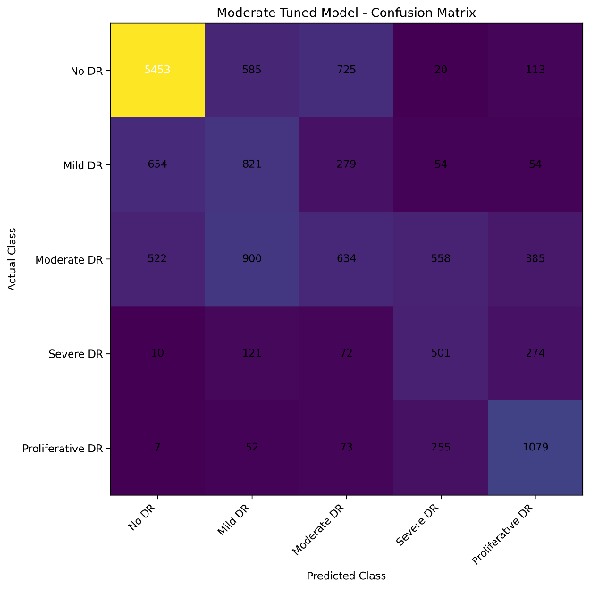
Fig. 2. Confusion Matrix of the EfficientNetB3 Model

B. Overall Classification Performance
Summing the diagonal entries gives 8,488 correct predictions from 14,201 test images. The resulting accuracy is:

Accuracy = (8,488 / 14,201) × 100

= 59.77%
This percentage summarises all test predictions but conceals the differences between categories. Table II therefore reports precision, recall, and F1-score for each grade.

TABLE II
CLASS-WISE PERFORMANCE OF EFFICIENTNETB3

DR Class | Precision (%) | Recall (%) | F1-Score (%)
No DR | 82.05 | 79.08 | 80.54
Mild DR | 33.11 | 44.09 | 37.82
Moderate DR | 35.55 | 21.14 | 26.52
Severe DR | 36.09 | 51.23 | 42.35
Proliferative DR | 56.65 | 73.60 | 64.01

C. Class-Wise Result Analysis
No DR achieves 79.08% recall and an F1-score of 80.54%. Proliferative DR also has comparatively high recall at 73.60%, whereas Mild and Severe DR reach 44.09% and 51.23%, respectively.
Moderate DR has a recall of 21.14% and an F1-score of 26.52%. Thus, most images carrying this label are assigned elsewhere. This weakness is also evident in the confusion matrix and limits the model’s usefulness for consistent five-grade assessment.

D. Training and Validation Accuracy
During the fine-tuning interval shown in Fig. 3, training accuracy varies from approximately 61% to 64%. Validation accuracy remains higher, at about 66%–67%. Both traces change relatively little after the early epochs, with the highest validation value appearing toward the end of the displayed interval.

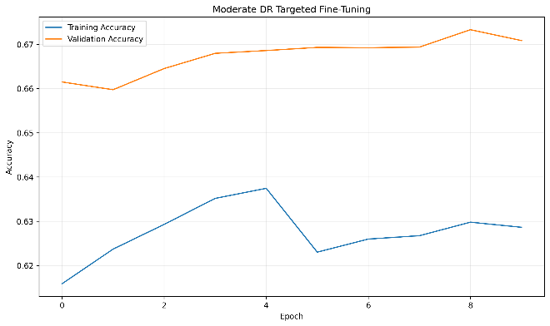

Fig. 3. Training and Validation Accuracy During Targeted Fine-Tuning

E. Training and Validation Loss
Figure 4 shows training loss falling from roughly 1.29 to 1.06. Validation loss reaches its minimum earlier and subsequently fluctuates around 0.99–1.03. The later epochs therefore show continued reduction in training loss without an equally sustained reduction in validation loss.

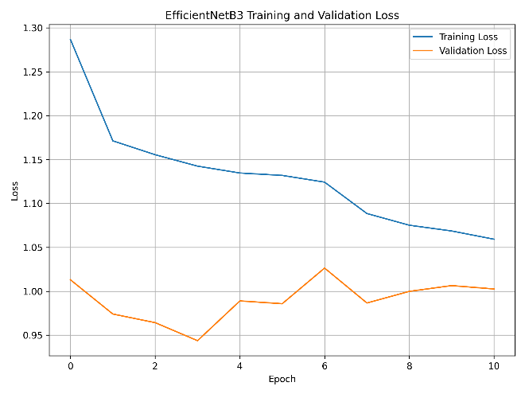
Fig. 4. Training and Validation Loss of EfficientNetB3

F. ROC Curve Analysis
Figure 5 reports AUC values of 0.8669 for No DR, 0.7096 for Mild DR, 0.5314 for Moderate DR, 0.8669 for Severe DR, and 0.9405 for Proliferative DR. The micro-average AUC is 0.8350.
Proliferative DR has the largest class-level AUC, while Moderate DR has the smallest. The weak Moderate DR result agrees with its low recall and frequent misclassification, demonstrating why the micro-average alone would give an incomplete account of this model.

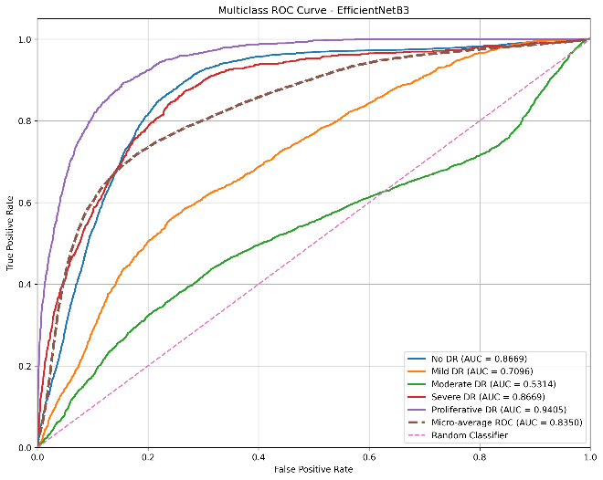

Fig. 5. Multiclass ROC Curve of the EfficientNetB3 Model

G. Grad-CAM Result Analysis
Figure 6 illustrates the Grad-CAM output for a prediction. The selected class response is used to generate a heatmap, which is then overlaid on the original fundus photograph for visual inspection.
The interface presents this overlay with the grade and confidence score. It gives spatial context to the network response, but the experiment does not establish the clinical validity of the highlighted regions.

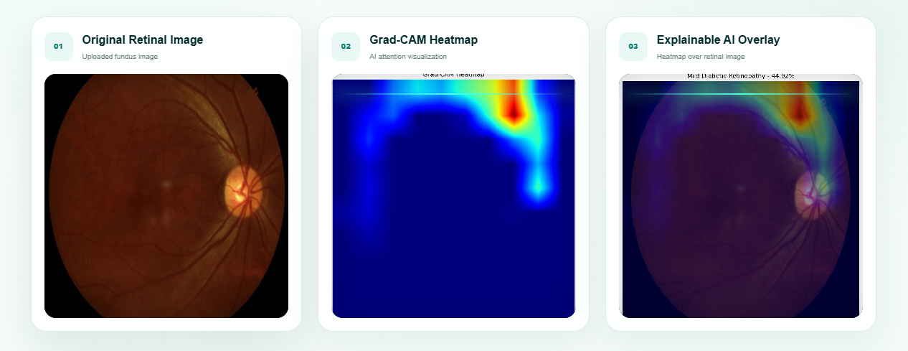

Fig. 6. Grad-CAM Visualization for Diabetic Retinopathy Prediction

VI. CONCLUSION
This study implements five-grade DR classification with EfficientNetB3 and presents its predictions through a Flask application with Grad-CAM overlays. Evaluation on 14,201 held-out images yields 8,488 correct classifications, an accuracy of 59.77%, and a micro-average AUC of 0.8350. These aggregate values mask pronounced differences across grades: recall is 79.08% for No DR and 73.60% for Proliferative DR, compared with 21.14% for Moderate DR. Improving recognition of intermediate disease stages is therefore a priority. Future experiments should investigate class balancing and further model tuning, followed by evaluation on additional retinal datasets. The current application demonstrates an integrated research workflow, but its reported performance does not establish readiness for clinical diagnosis.

REFERENCES
[1] A. Sebastian, O. Elharrouss, S. Al-Maadeed, and N. Almaadeed, “A survey on deep-learning-based diabetic retinopathy classification,” Diagnostics, vol. 13, no. 3, Art. no. 345, 2023, doi: 10.3390/diagnostics13030345.
[2] T. M. Usman, Y. K. Saheed, A. Nsang, A. Ajibesin, and S. Rakshit, “A systematic literature review of machine learning based risk prediction models for diabetic retinopathy progression,” Artificial Intelligence in Medicine, vol. 143, Art. no. 102617, 2023, doi: 10.1016/j.artmed.2023.102617.
[3] R. Sarki, K. Ahmed, H. Wang, Y. Zhang, and K. Wang, “Diabetic retinopathy detection through deep learning techniques: A review,” Informatics in Medicine Unlocked, vol. 20, Art. no. 100377, 2020, doi: 10.1016/j.imu.2020.100377.
[4] B. Tymchenko, P. Marchenko, and D. Spodarets, “Deep learning for diabetic retinopathy detection and classification based on fundus images: A review,” Computers in Biology and Medicine, vol. 135, Art. no. 104599, 2021, doi: 10.1016/j.compbiomed.2021.104599.
[5] W. L. Alyoubi, W. M. Shalash, and M. F. Abulkhair, “Deep learning based computer-aided diagnosis systems for diabetic retinopathy: A survey,” Artificial Intelligence in Medicine, vol. 99, Art. no. 101701, 2019, doi: 10.1016/j.artmed.2019.07.009.
[6] S. Shekar, S. Satish, and K. N. S. Prasad, “Review on diabetic retinopathy with deep learning methods,” Journal of Medical Imaging, 2021.
[7] H. Naz, N. J. Ahuja, and R. Nijhawan, “Diabetic retinopathy detection using supervised and unsupervised deep learning: A review study,” Artificial Intelligence Review, vol. 57, Art. no. 131, 2024.
[8] “Deep learning for diabetic retinopathy analysis: A review, research challenges, and future directions,” 2022.

